**Gender Equality**

**Home**

Gender Equality is the state wherein both men and women have access to equal rights in terms of social, cultural, and political manner. It entails that all, regardless of gender, lives in the same world and therefore requires equal access of the law and its protection.

**Mission-vision**

We envision a society where both men and women experience no discrepancies in terms of rights and equality. Thus it is our mission to promote and disseminate our cause to further advocate gender equality.

**History**

The history of gender roles for men and women in the Philippines goes way back during the time when our ancestors lived a traditional life without the influence of the colonials. Back then, men and women shared equal rights and status in the society. In fact, one of their important figures in the past known as the “Babaylan”, is a woman respected for her wisdom and healing abilities. A man disrespecting a woman is unthinkable therefore our ancestors in the past strived together, regardless of gender.

  Then came the Spanish, they influence the idea that women are inferior and therefore must remain in the shadows of men. Their idea of a woman is one who is submissive and someone who stays at home as a good daughter, a wife, and a mother. Rights for education, politics, and freedom of women during the Spanish era were harshly suppressed. It was a dark time for gender equality. Nonetheless, many historical women rose in the Spanish era. Two of them are Gabriela Silang and Gregoria de Jesus. Both of them showed that even women can rush in the midst of battle alongside men.

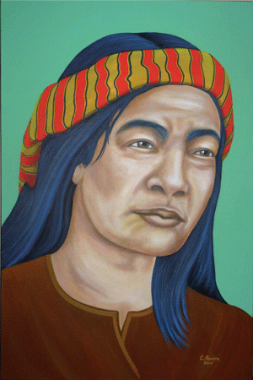

Gabriela Silang is a prominent figure known as the “Philippines’ Joan of Arc”. She is the wife of Diego Silang who bravely led the war after his husband’s death.

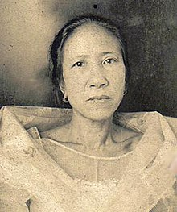

Gregoria de Jesus is someone who fought bravely alongside his husband, Andres Bonifacio, and the members of the Katipunan.

  After the Spanish era came the Americans. In this era, the idea of gender equality are slowly returning to the Filipinos. Mem and women are given equal rights to education and political power. They were given freedom to choose their paths just like men.

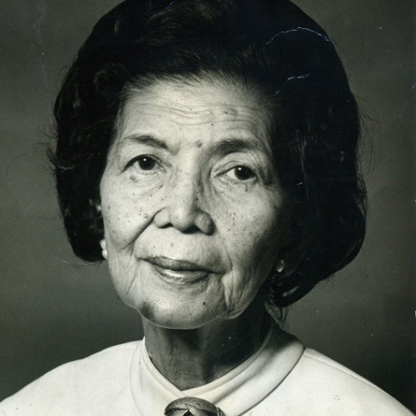

One of the prominent figures in this era is Fe Del Mundo. She is the first female to graduate in Harvard School of Medicine. She proved that women are not just meant to be inside the house, they can do things that man can, if only given the proper right and the freedom to do so.

  In today’s era, gender equality is improving as time ages. Laws are implemented to protect both men and women’s freedom and rights. Though gender equality are still lacking in some aspects, we believe that with proper dissemination of information to the society, there will come a time when gender equality will be a subject both accepted and embraced. Because before we were colonized, we Filipinos were first and foremost a great example of a society with equal rights regardless of gender.  

**Be Aware**

According to the data we accumulated by interviewing the barangay officials of Bakakeng Norte, Baguio City; 7 out of 10 of their staff composed of women, excluded of the barangay Tanods. Most of the Tanods are composed of men. According to them, some women also joins the workforce of the barangay Tanod. There was also a time when the chief barangay Tanod was a woman. The officials treat their co-workers equally regardless of gender. They said that in terms of efficiency, all of the officials are equally hardworking and dependable on their task. This proves that gender equality are slowly improving.

“We are children of Gabriela” said one of the female barangay official.  The barangay aims to promote gender equality by organizing projects and seminars to the citizens of the barangay.

“We believe that education is the key. We need to wash out the old ideals that men are superior to women. God sees us equally, it’s time we think the same to our friends.” said one of the barangay official.

Though the supporters of gender equality are increasing, some are still stuck in the old ideals. When we asked an anonymous repairman about his opinion for a woman doing repair work, he said “How can a woman wearing dress and frizzy clothes could work as a repairman?” In contrast to his opinion, women can do a man’s work and at the same time men can also do a women’s work.

Here are some notable men and women who proved that ability is not dependent on gender.

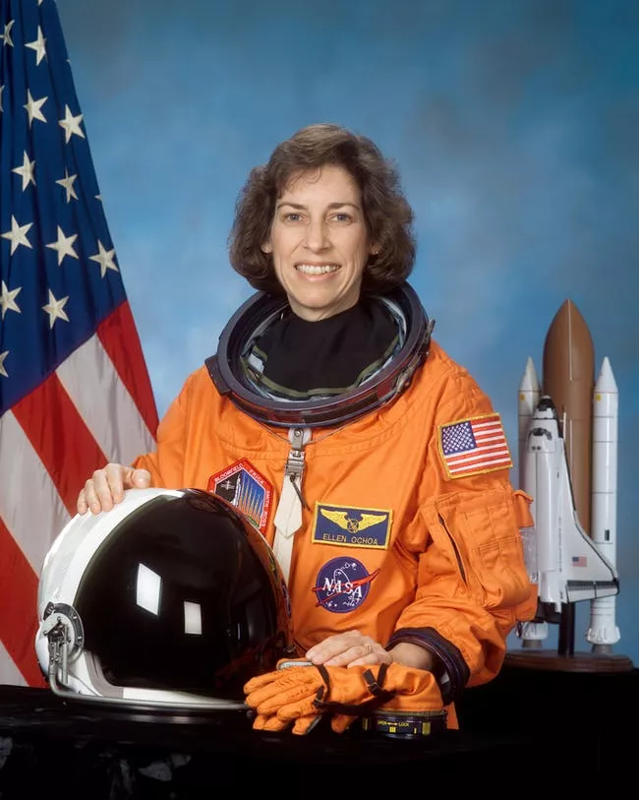

Ellen Lauri Ochoa, a female astronaut.

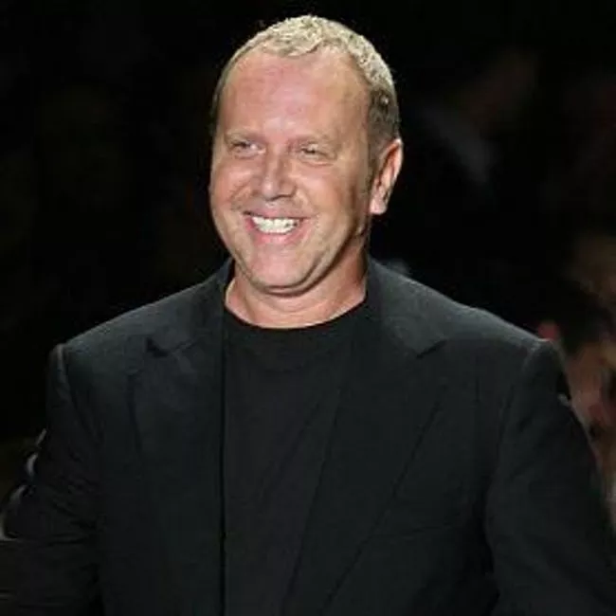

Michael Kors, a fashion designer based in New York.

Gender equality entails that everyone has the freedom to be anyone with proper commitment and hard work.

**Be involved**

Gender Equality all starts from you. Here are some ways that you can promote the advocacy.

1. Listen to both sides.

* Before jumping to conclusions, learn to understand the opinions of both men and women.

1. Do not judge by its gender.

* Do not judge a person’s ability and status by its gender.

1. No gender is superior to the other.

* Men and women are equally same in rights, freedom, and responsibilities.

1. Be a good model.

* By being a good advocator of gender equality, others would follow your ideals instead of the old belief that men are not equal with women.

1. Never limit your ability base on gender.

* You can do anything as long as you have the motivation to do it. Gender will not limit what you can do.

1. Never think lowly of yourself.

Start with yourself, do not think that the others are superior that you because of gender. Accept and be proud of who you are.

**About us**

**Resources**

http://www.hawaii.edu/cps/filipino.html

https://tonkshistory.wordpress.com/2012/02/22/the-role-of-women-from-pre-hispanic-to-spanish-era/

http://preen.inquirer.net/8226/the-five-women-who-moved-filipino-history-forward

http://www.filipiknow.net/facts-about-pre-colonial-philippines/

https://en.wikipedia.org/wiki/History_of_the_Philippines_(900%E2%80%931521)

https://www.workflowmax.com/blog/7-famous-female-engineers-in-history

http://teacher.scholastic.com/activities/women/notable.htm

https://www.ranker.com/list/famous-female-soldiers/reference

https://www.ranker.com/list/famous-female-astronauts/reference

https://www.ranker.com/list/famous-male-fashion-designers/reference

http://maelstromcore.com/sandbox/wp-content/uploads/2014/03/19370.gif

https://upload.wikimedia.org/wikipedia/en/thumb/5/54/Gregoria_de_Jes%C3%BAs.jpg/220px-Gregoria_de_Jes%C3%BAs.jpg